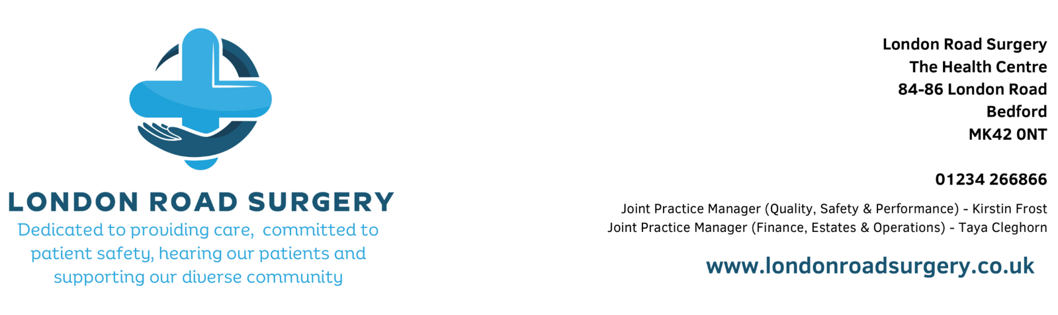
Non-NHS Work Request

While most services at London Road Surgery is funded by the NHS and free for patients, there are some services that fall outside of NHS funding. These are known as Non-NHS services and may include things like medical reports for insurance, letters for employers or schools, and certain medical forms. These services incur a fee.

Important Information

- Fees Apply: We charge for non-NHS work. Fees depend on the type of request and the time it takes. A full list is available below.

- Upfront Payment: Once your request has been accepted we require payment before we start any non-NHS work.

- Fee Range: Where a fee range is given, the minimum fee is charged upfront. If more work is needed, any balance is payable on collection.

- Turnaround Time: Please allow 4-6 weeks for completion. We do not offer an urgent or fast-track service.

- Patient Consent: We need your written consent before sharing any medical information.

- We May Decline: GPs are not required to complete all non-NHS requests. If a request is inappropriate or outside of a GP’s role (such as non-medical character references), we will let you know and explain your options.

Section 1: Patient details
Surname |  | NHS number
Forename |  | Telephone no.
Date of birth |  | Address:
Section 2: Services requested
Services requested | Provide as much detail as possible
For Internal Use Only
Request Reviewed | Staff initials and date to confirm request has been accepted – to be completed within 3 working days. If further information is required record here.
Fees applicable
Terms and conditions of the service | Insert specifics here:
Additional costs | The following are potential additional costs:
Refund information
Section 3: Payment (advise patient about payment terms)
Payment by card (ensure receipt is issued)
Section 4: Patient declaration and signature:
I understand that the service(s) I have requested is/are not funded by the NHS and I accept the fee(s). I have been advised of any potential additional costs, the terms and conditions of the service and the circumstances in which a refund may be applicable.
Patient signature and date
Print name
A copy of this completed pro forma is to be scanned and saved in the individual’s healthcare record and a copy passed to the patient.

Table of Fees

Statement of Costs

The services detailed in the table below are NOT funded by the NHS and therefore have an associated cost.

Non-NHS service | Fee
Driving
- Emergency treatment (Road Traffic Act) | £40.00
- Seat belt exemption letter | £40.00
- Report for DVLA with full medical | £80.00
- Report for DVLA without full medical | £40.00
- Driving Medicals (Taxi, HGV & PSV) | £80.00
- PCV company application form | £28.00
Certificates, forms and reports
- Childminder health forms (OFSTED) | £96.00
- To Whom It May Concern | £30.00 to £80.00 (dependent on amount of work)
- Sickness or accident claim form | £40.00
- Cancellation of holiday form | £40.00
- Private sick notes | £30.00
- Doctors signature on insurance forms | £40.00 to £80.00
- Adoption form AH | £80.00
- Fostering form AH2 | £30.00
- Private health insurance claim forms | £80.00
- Medical report (extract from medical record) | £80.00
- Firearms (certificate only) | £40.00
- Police enforcement report | £40.00
Photograph verification  - Driving licence  - Passports | Not Available
Miscellaneous  - Firearms (certificate only)  - DSA  - Mental Capacity Assessment  (limited availability of doctors who are able to  complete) | £40.00  £40.00  £80.00 (face to face)  £120.00 (home visit)
Not Chargeable  - Patient medical Summary  - Copies of individual clinic letter, hospital letters or test results  - Council tax exemption | Not Chargeable

If you require a service not detailed on this statement, please enquire at reception.

